Artevelde Unversity College

Daan Penders  
Seppe Huysman  
Ian Martens  
Kevin Kielbaey  
Pieter-Jan Westelinck

Report

Business management survey at Artevelde University college



# Executive Summary

This survey and its conclusions are based on the answers of thirty second year students who study Business Management - Marketing at the Artevelde University College in Gent. One of the most positive aspects of the program are the available specializations. Almost all students are satisfied with the available options. Another positive point is the amount of language courses. The majority of the students are satisfied with the current amount of languages and classes. Next there is the power distance (are teachers easily approachable, can students disagree or discuss with teachers,…) between teachers and students. In general the students are happy with the power distance although there are quite some students who think it can be better.

Of course there are also some negative aspects about the program. Around 43% are not satisfied with the use and communication through Chamilo. When we asked them if they are satisfied with how MijnDinar works, over half of the students responded negatively. We can conclude that the Artevelde University College should invest more time in their online platforms. We also found out that around one in three students have no idea if they will have the required skills for a job when they graduate. When asked about the available accommodation almost all students were satisfied. To conclude we can say that the majority of the students have an overall positive experience at the Artevelde University College.

Table of contents

Executive Summary 1

Introduction 3

Results 4

Conclusion 12

Recommendations 13

Sources 14

Appendix 1 15

# Introduction

In this survey we asked the students of the second year Business Management, specialization marketing, fifteen questions about how they experience the program Business Management at the Artevelde University College in Gent. We have tried to assess the positive and negative points of the Program Business management in general, how classes are taught, the study load etc. After all the data was analyzed, the findings and conclusions were written in the report below.

# Results

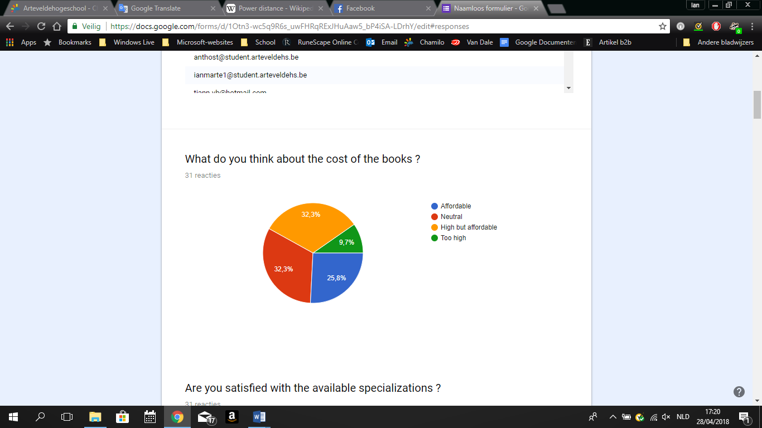

It looks like the costs of the books at Artevelde are affordable for most students. Only 10% of the students answered that the price is too high and more than half of the students think the price is not.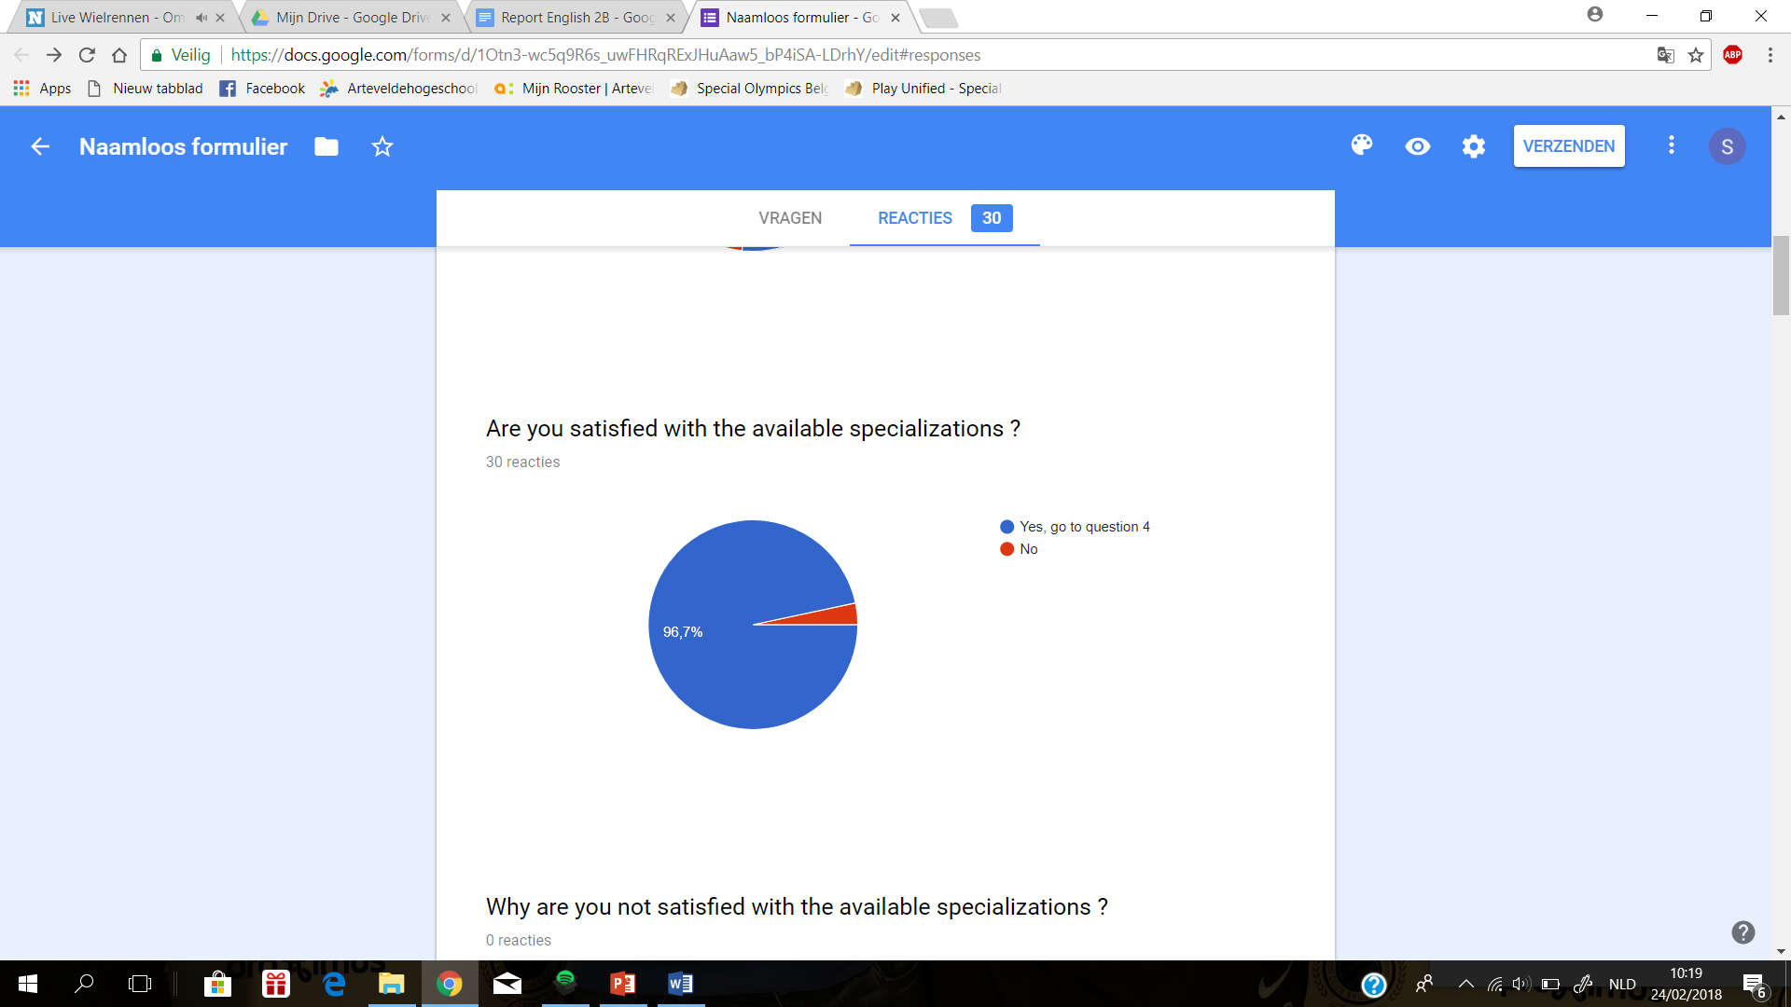

Out of the thirty students that replied only one of them thinks there aren’t enough specializations to choose from. This means that 97% of the students are satisfied with the available specializations, which is a very positive result.

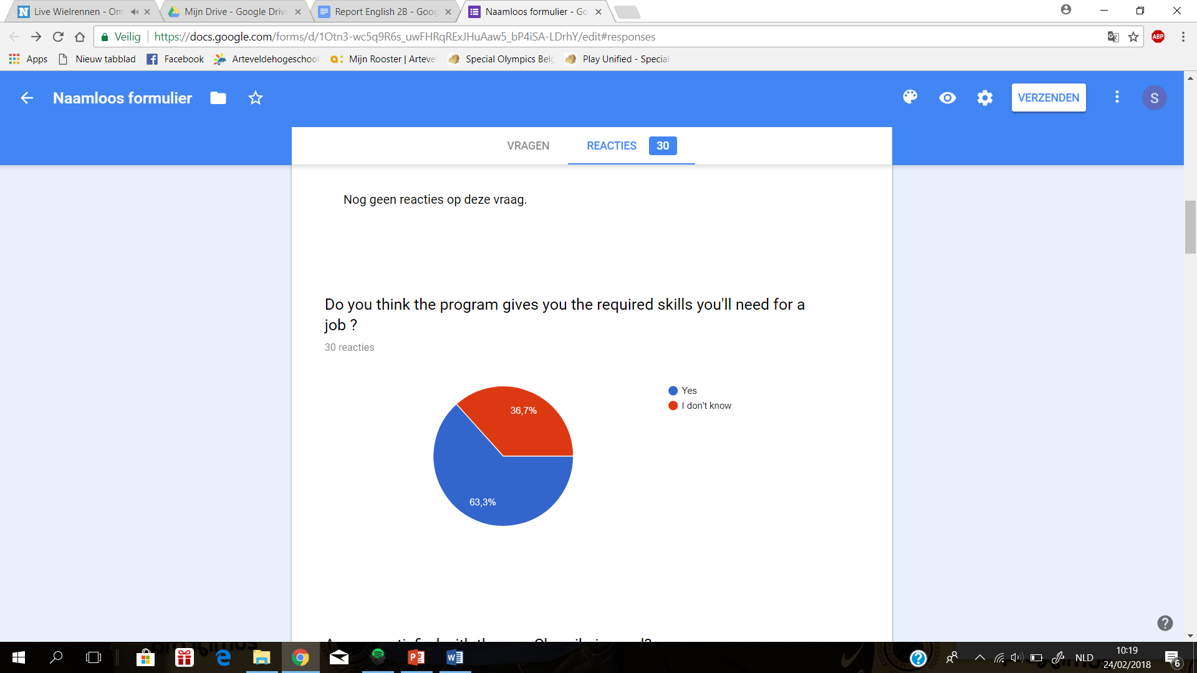

More than 6 out of 10 students believe that this program gives them the required skills that they will need for their job. A third of the students don’t know for sure that this program will give them the skills they will need. Maybe it would help if the lecturers gave some more examples of how the theory that is taught in class is applied in real life business cases.

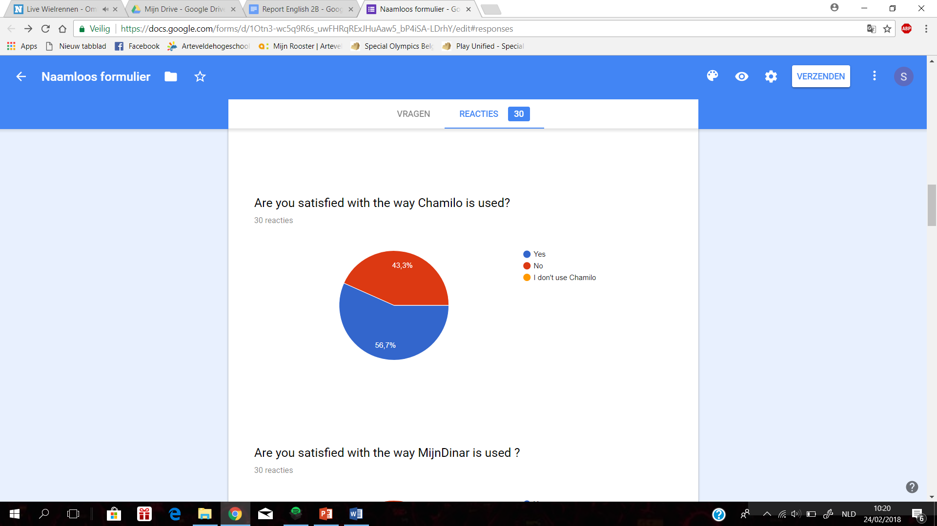

This graph shows ~~us~~ that 43% of the students are not satisfied with the way Chamilo is used. We think that’s a lot and that something has to be done about it. We have to investigate why people are not satisfied with the use of Chamilo and how we can improve their experience with the online platform.

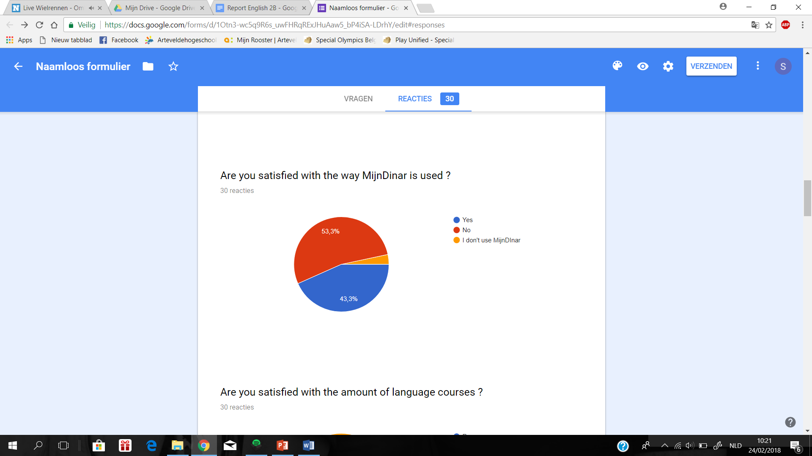

When we take a look at the second online platform that Artevelde uses, MijnDinar, we can see that most students are not satisfied with their online experience either. There are even students who don’t use it at all. This shows ~~us~~ that Artevelde really needs to invest in the online platforms that are being used.

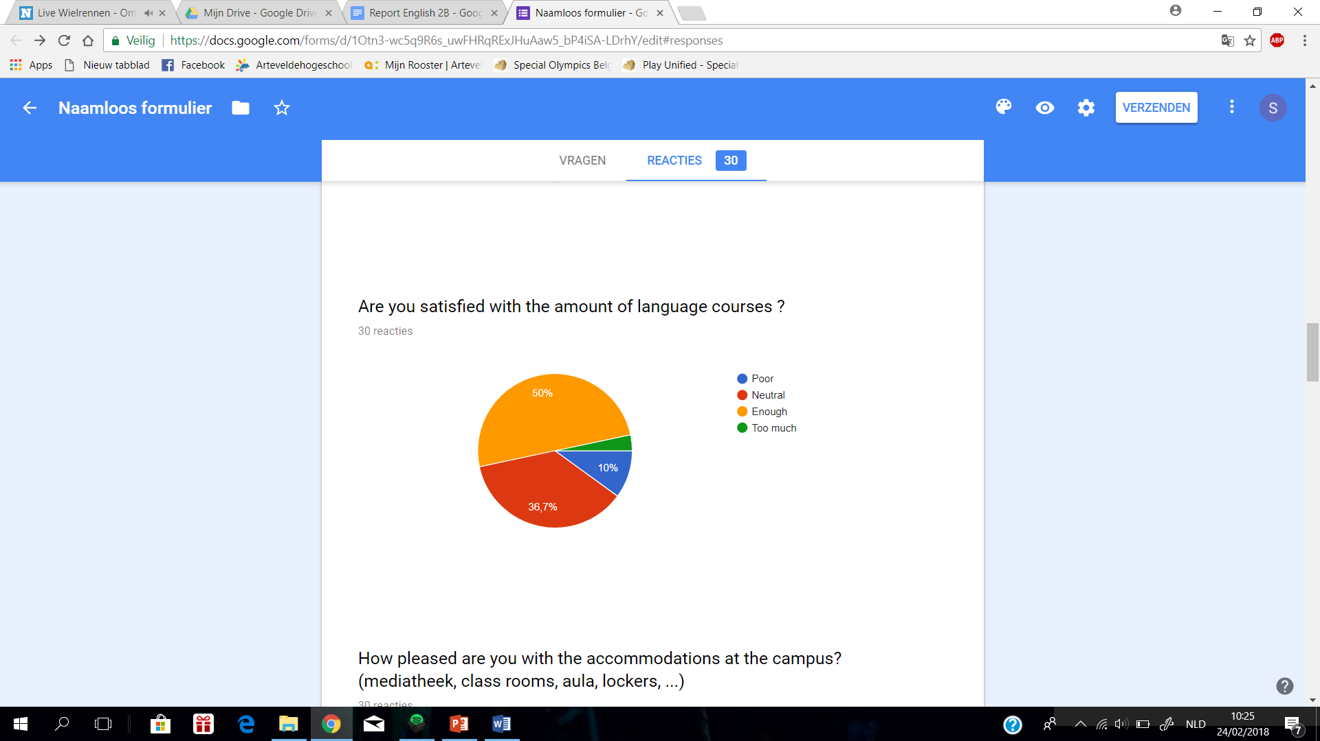

The majority of the students say that they are either neutral or satisfied with the amount of language courses. This means the amount of language courses can remain unchanged.

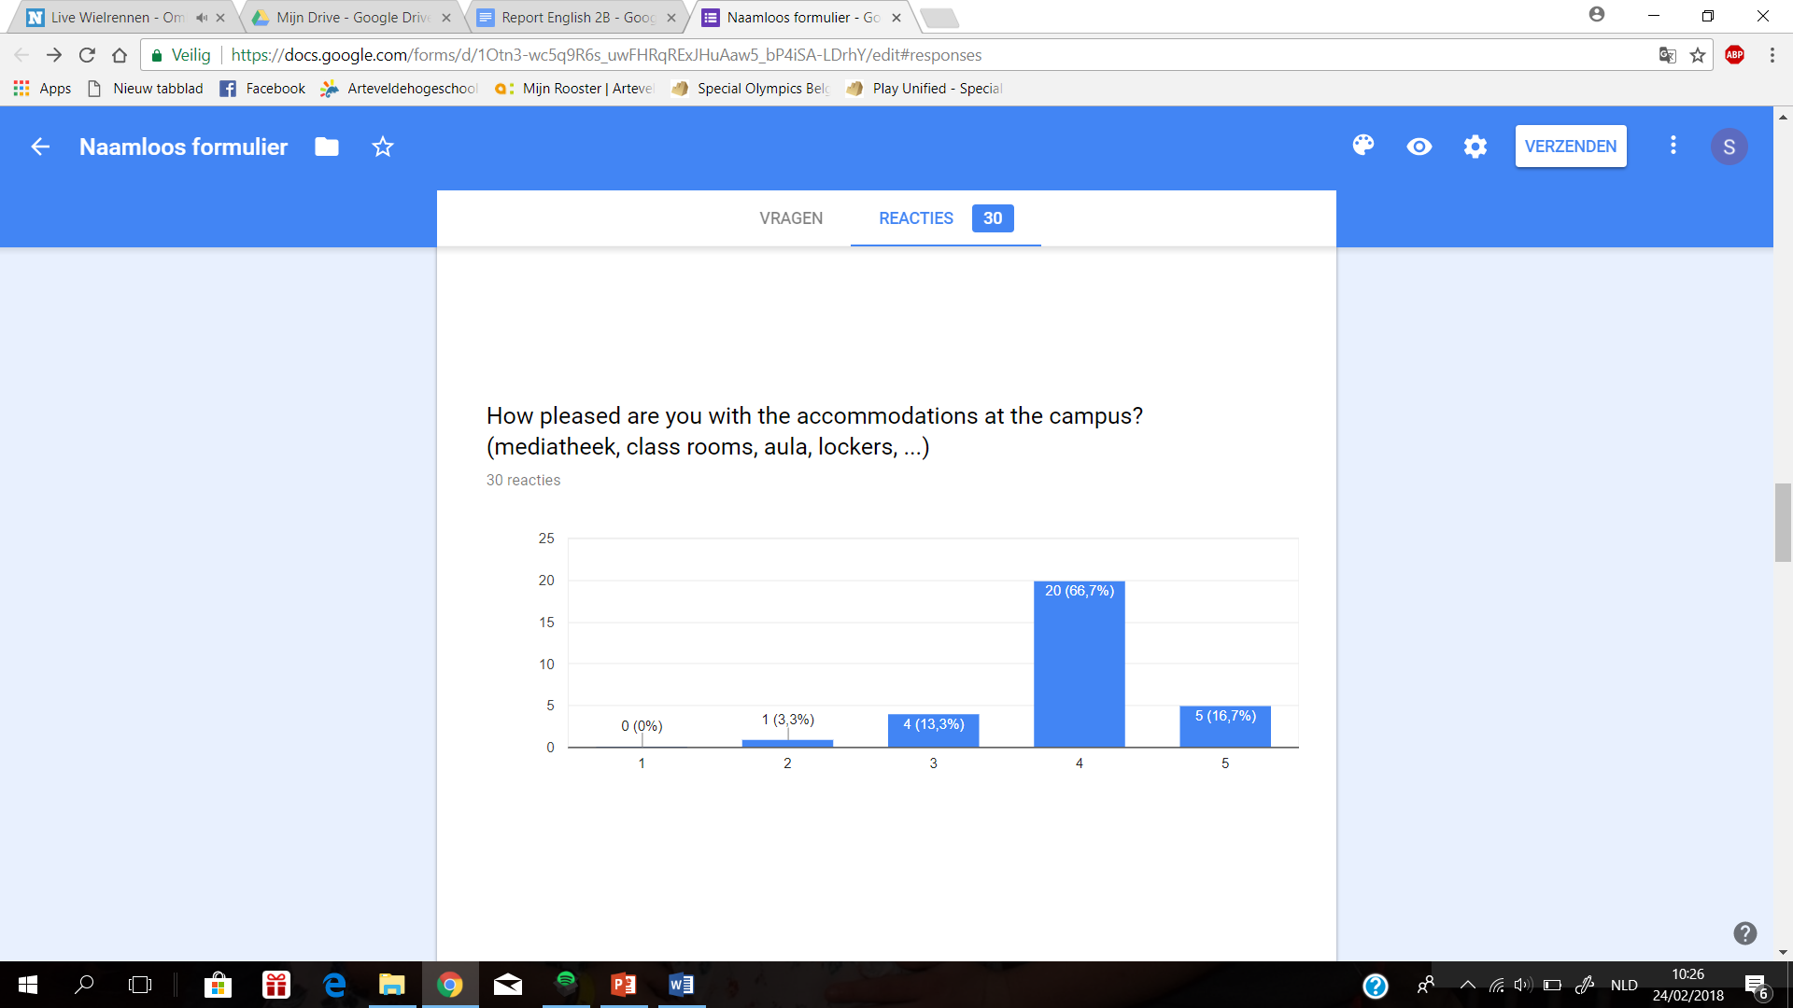

The graph shows that students are satisfied with the accommodations at the campus. More than 80% of the students gave the accommodations a positive score.

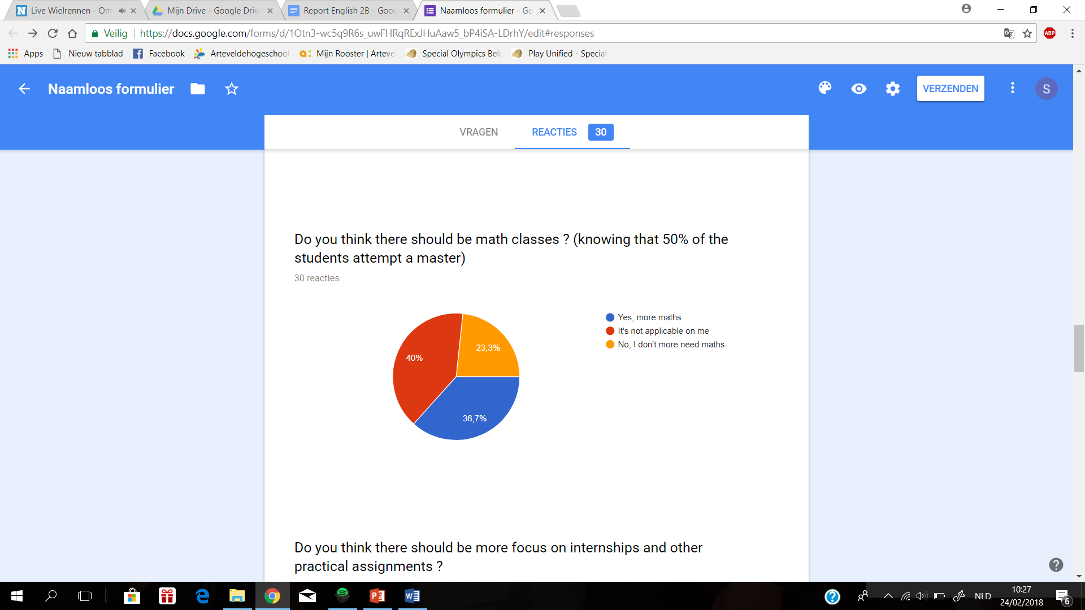

Two thirds of the students don’t want or don’t need mathematics classes. However, 36.7% of the students would agree on having math classes since it is very helpful for a master degree.

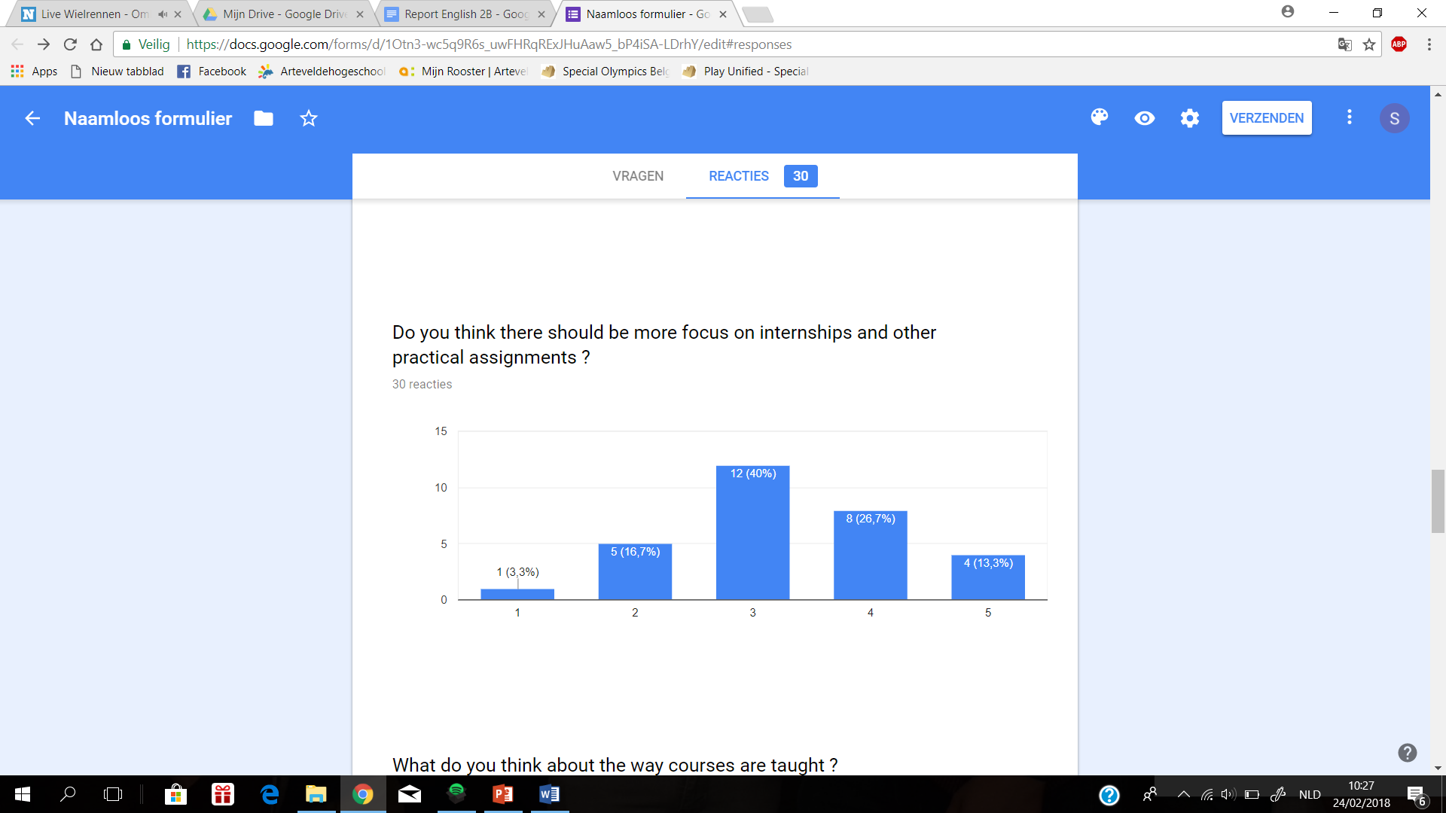

The opinions are divided regarding whether there should be more focus on internships and other practical assignments.  
However, there are slightly more students who think the program should have a more practical approach.

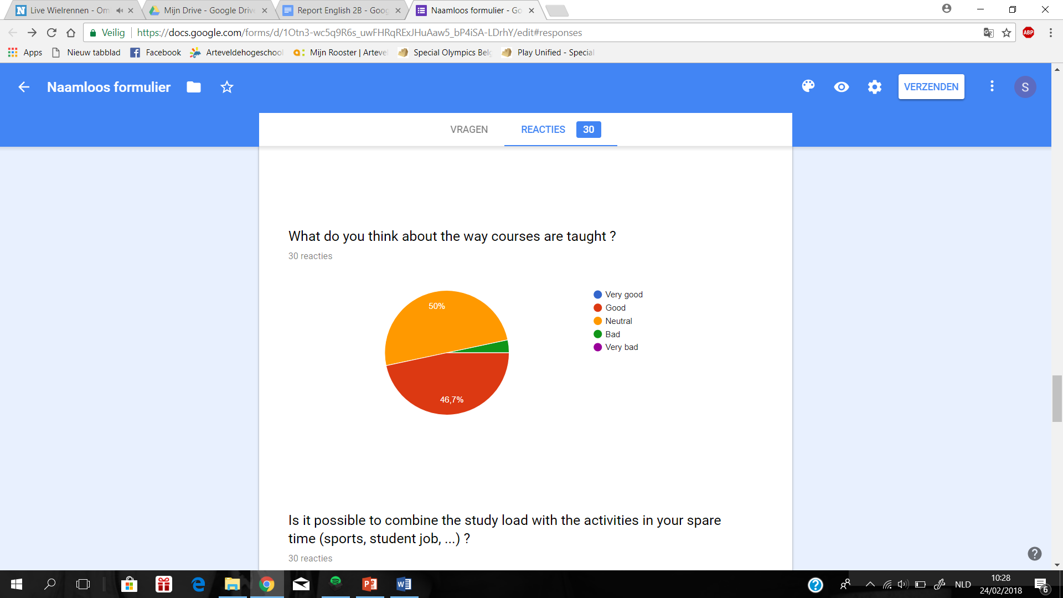

Over 95% of the students agree that the courses are, in general, not taught in a bad way.

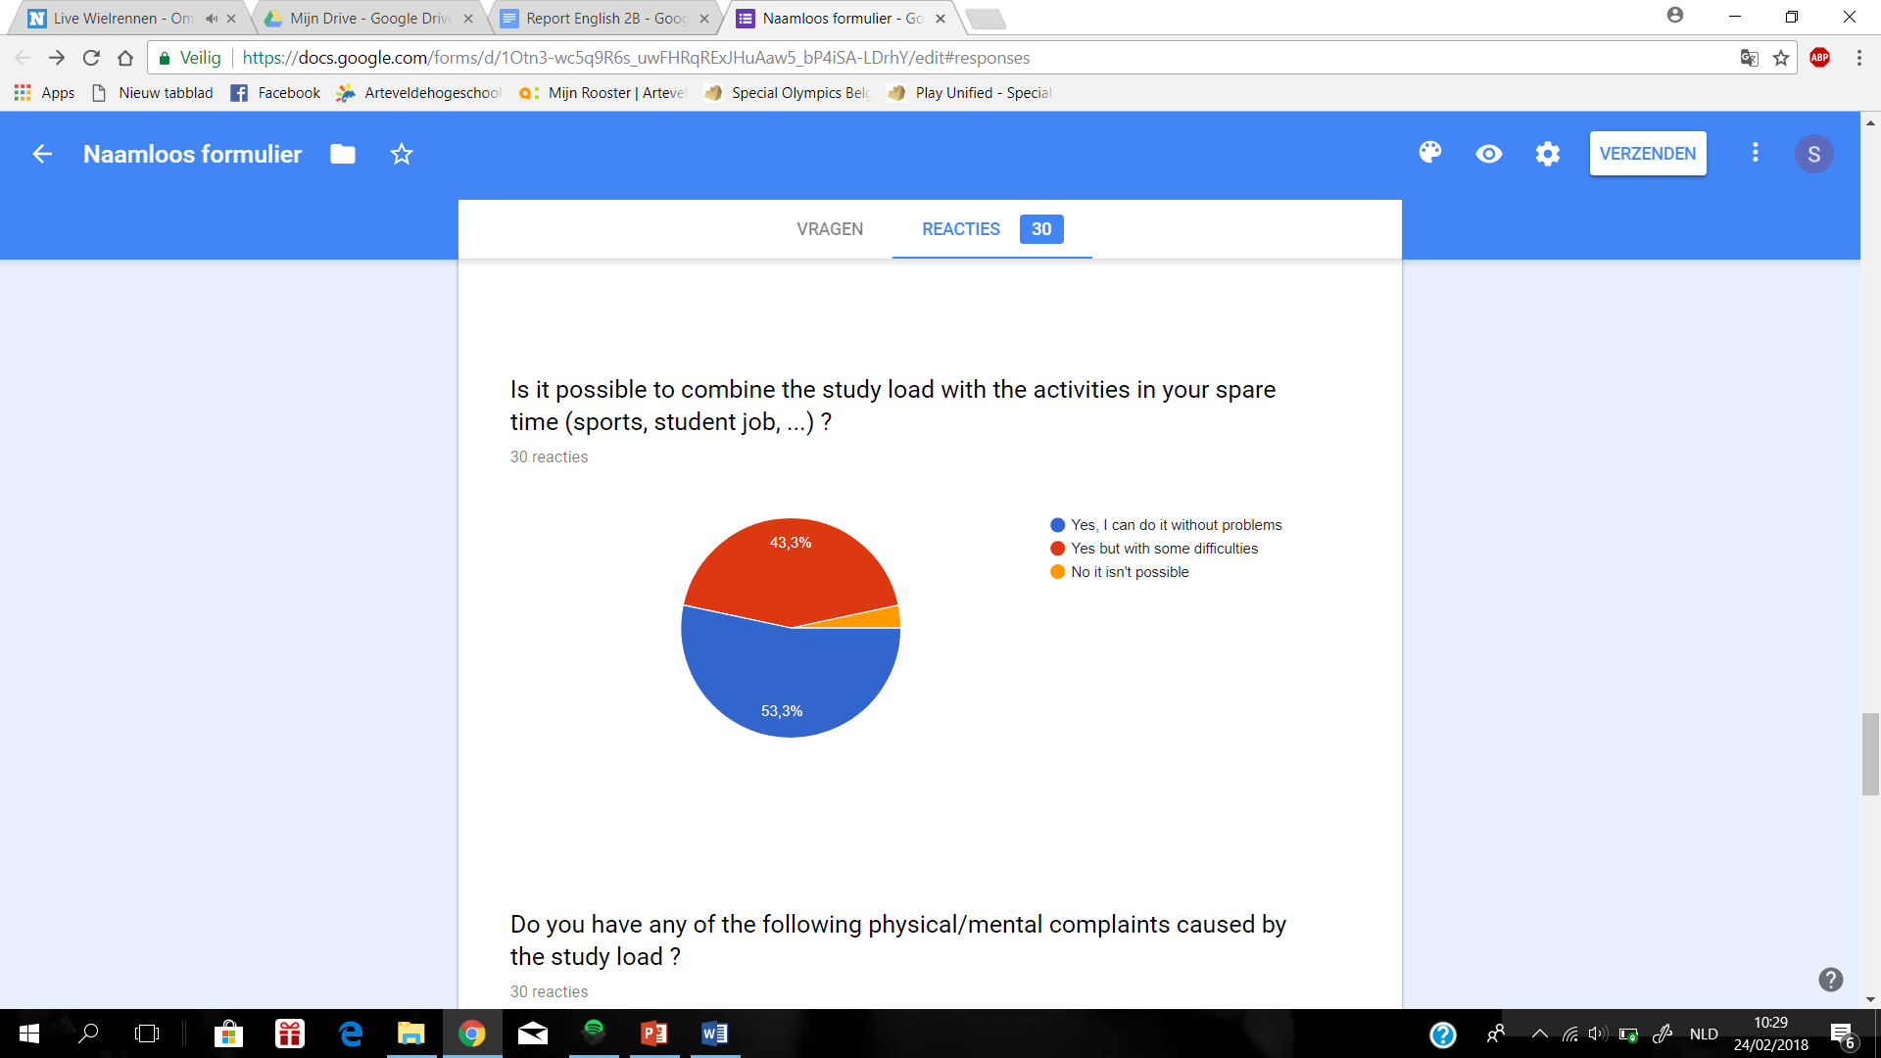

A small majority thinks that the study load of this program can be combined with activities in their spare time without any troubles. Almost everyone agrees that the two can be combined, however 43% thinks this comes with some difficulties.

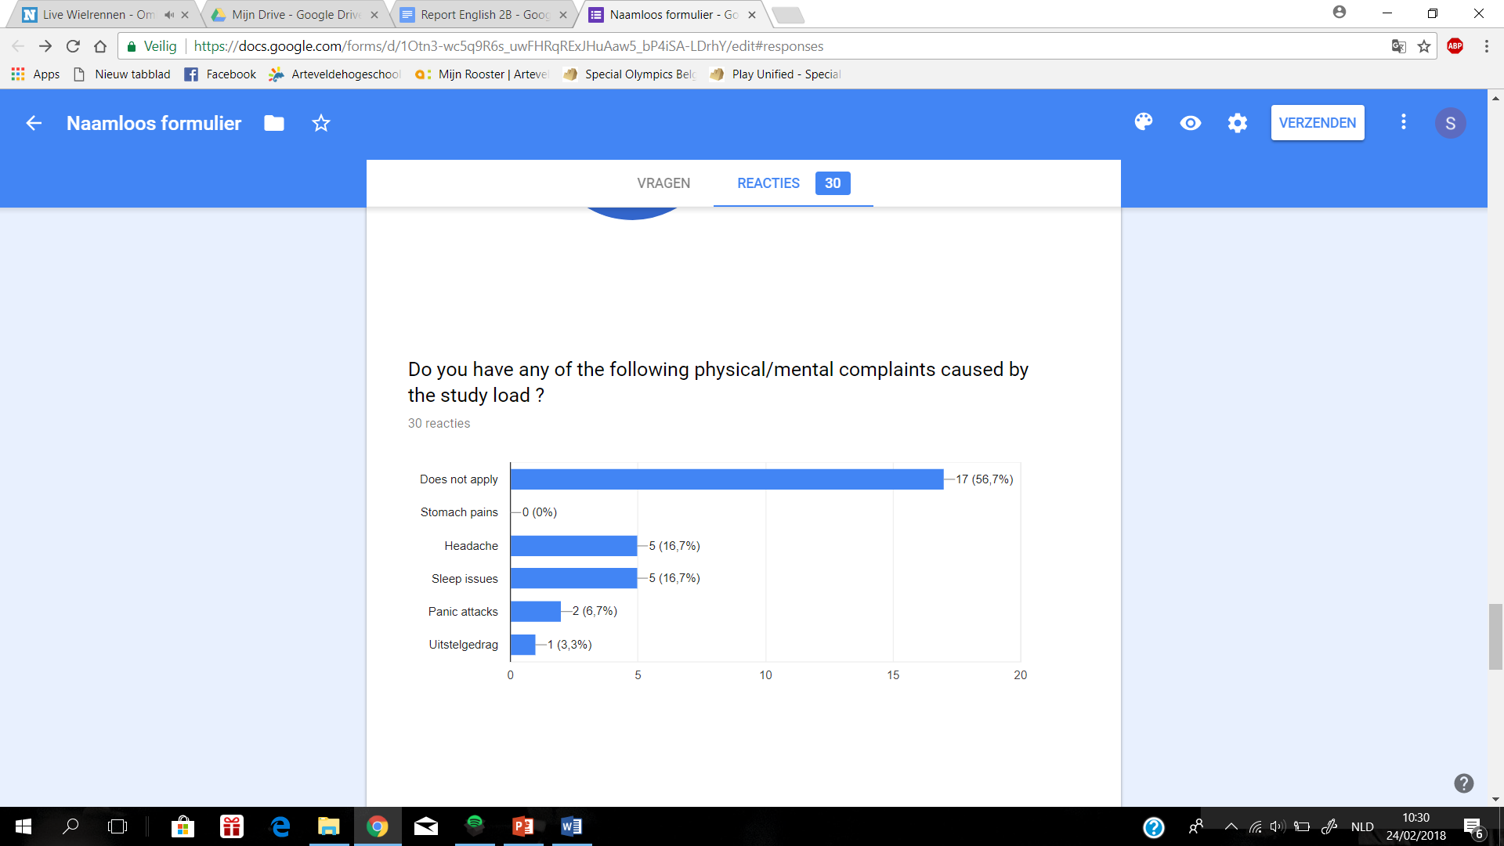

The majority of students doesn’t experience any physical or mental complaints caused by the study load. However, over 30% of the students claim to suffer from headaches and sleep issues.

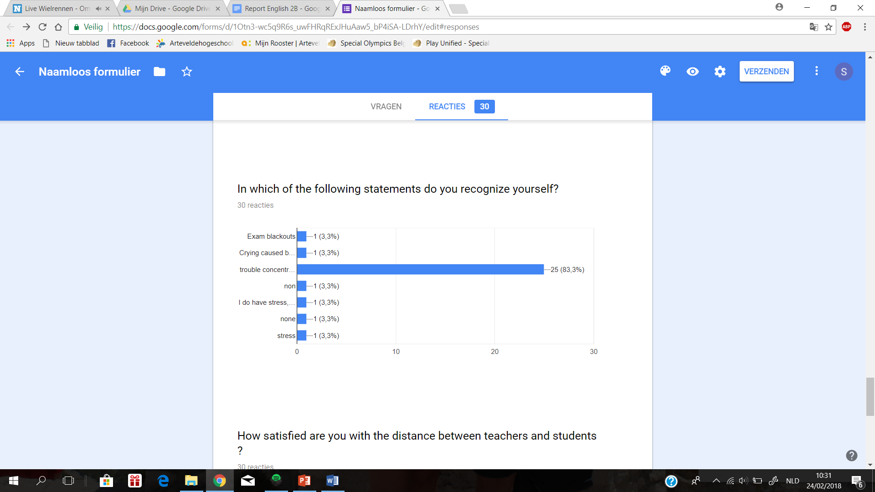

On this graph we notice one outlier. Over 80% of students answered that they have trouble concentrating when they are studying or working for school. All the other statements received equally low & negligible responses.

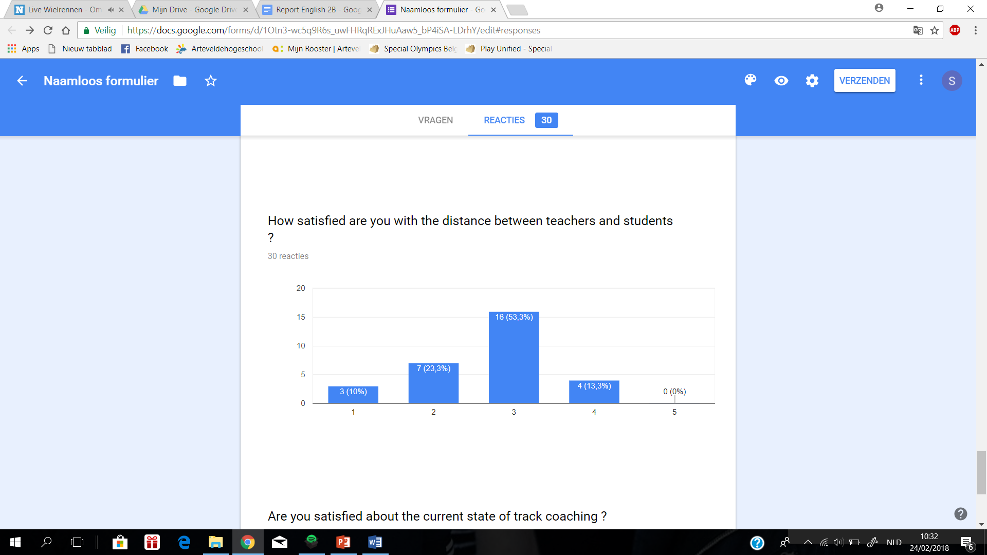

Approximately half of the students answer neutral when asked about the distance between teachers and students.   
What we can see is that over 20% of the students aren’t satisfied with this distance.  
10% of students even stated that they were very unsatisfied.  
We can also see that there are absolutely no students who think the current power distance is perfect.

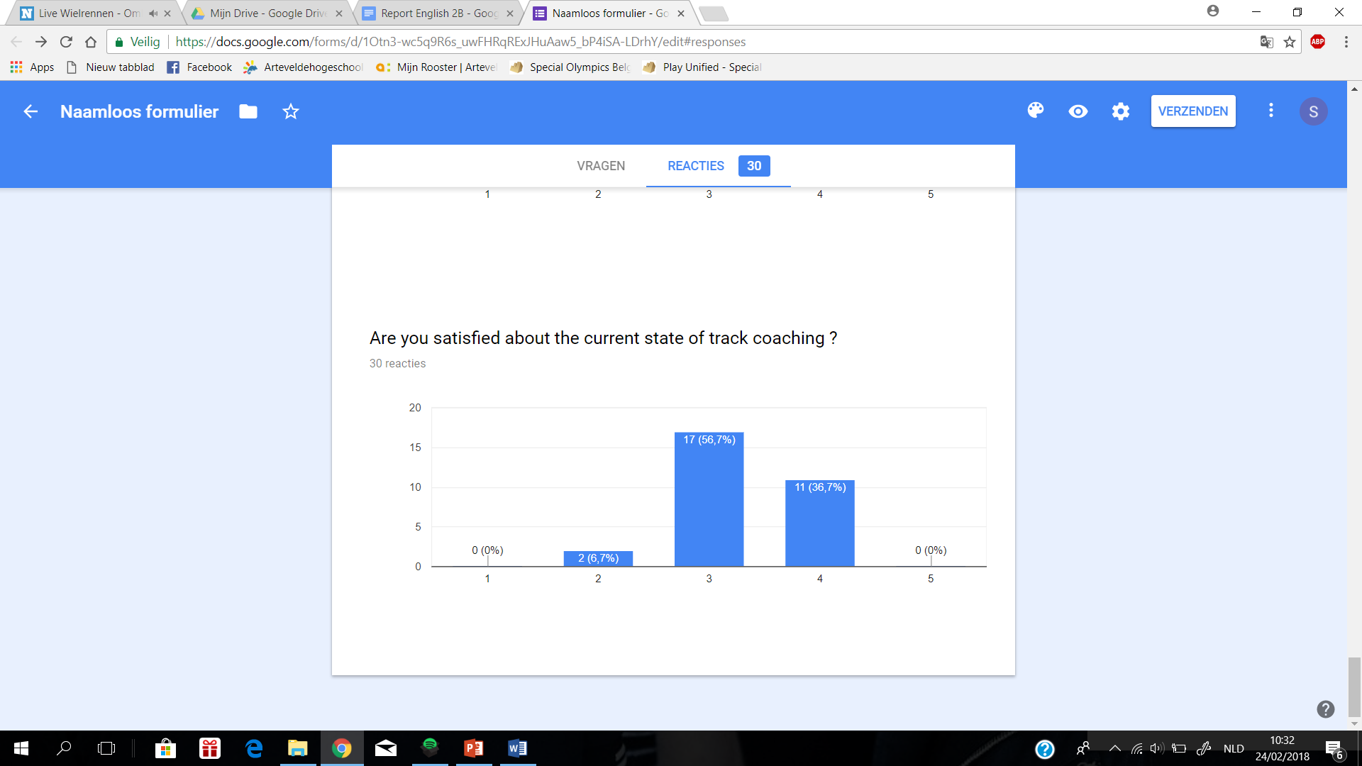

In general this graph shows us that the vast majority of students are neutrally satisfied or even quite satisfied with the current state of track coaching.

# Conclusion

We managed to get 30 students to fill in our online survey. Based on these answers we concluded some positive and some negative aspects of the business management program at Artevelde.

Almost every student is satisfied with the available specializations that Artevelde is offering. The largest part of the students are convinced that they will meet the required skills for a job after they ~~graduated~~ graduate, although more than 1 out of 3 students are not sure they will be ready for a job when they graduate, which is a fairly high number.

The questions about the online platforms of Artevelde show a big difference between the results. Chamilo only gets an approval rate of 57% , which means that 43% is not satisfied with the way it works. MijnDinar, another important online platform, does even worse with 53% of the students who aren’t happy with the way it works. So Artevelde should really invest in making their online platforms more accessible for the students.

The amount of language courses taught is in general enough for the average student. Math however gets a different feedback. Since it isn’t taught at Artevelde some people would like to have a math class as well so it is easier for them if they want to get a master degree. However, the largest amount of students don’t want a math class or don’t think it’s necessary for them. ~~As for~~ The teachers ~~they~~ get an overall positive feedback for the way the courses are taught. The students are also satisfied with the possible accommodations that are available at the campus such as the mediatheek, classrooms, ….

Most student don’t suffer from mental and/or physical health problems caused by the study load which is a very positive aspect to remark. Some students can have sleep issues and headaches but most of the time only temporary. Their social life and activities don’t suffer too much from the study load, the students say it isn’t always easy to manage both at one time but it is possible.

The questions about the online platforms of Artevelde show a big difference between the results.

# Recommendations

This survey has shown that circa fifty percent of the students at Artevelde University College are not satisfied at all about the use of the online platforms “MijnDinar” and “Chamilo”. Because these platforms have to be used almost every day we recommend the school to find out what exactly bothers the students so much and change it.

The survey has also shown that around thirty percent of the students are not sure if the program will teach them the required skills for a job. That’s why we recommend to integrate more business cases into the lessons so the students see how the theory is applied to solve problems they might encounter on the job.

Last but not least we would recommend to have an optional mathematics class in the third year so that students who want to get a master degree have an easier transition.

# Sources

Martens, I., Kielbaey, K., Huysman, S., Penders, D., & Westelinck, P.-J. (2018, februari). *Business management survey at Artevelde University college.* Opgehaald van Google: https://docs.google.com/forms/d/1Otn3-wc5q9R6s_uwFHRqRExJHuAaw5_bP4iSA-LDrhY/edit#responses

# Appendix 1

If our target group would be all the students who study business management, instead of only the ones who study marketing, we wouldn’t have to change any questions. All questions are general questions. All students use Chamilo, MijnDinar, the campuses etc. and there are no questions that can only be answered by marketing students.